**Diagnosis of Alzheimer’s Disease Using Convolutional Neural Network with Select Slices by Landmark on Hippocampus in MRI Images**

Diagnosis of Alzheimer’s Disease Using Convolutional Neural Network With Select Slices by Landmark on Hippocampus in MRI Images

Alzheimer is brain related diseases which must be diagnose and treat in early stages to save patient life. In the past many machine and deep learning algorithms were using to predict this disease but all those algorithm were taking entire MRI scan input for prediction which is degrading prediction accuracy as entire image may contains irrelevant features which will be diagnose incorrectly. In Alzheimer patient Hippocampus is the main region which is mostly affected so author of this paper employing novel technique to extract affected regions such as Axial, Coronal and Sagittal from MRI scan images and this extracted brain images region will get trained with different deep learning algorithms such as Pre-trained Resnet50, Resnet50 and LENET and in all algorithms LENET is giving better accuracy.

In propose paper author has extracted regions manually by using experts from ADNI dataset and not publish on internet so we have downloaded available dataset images from GOOGLE and then train with above mention algorithms.

In below screen showing dataset details

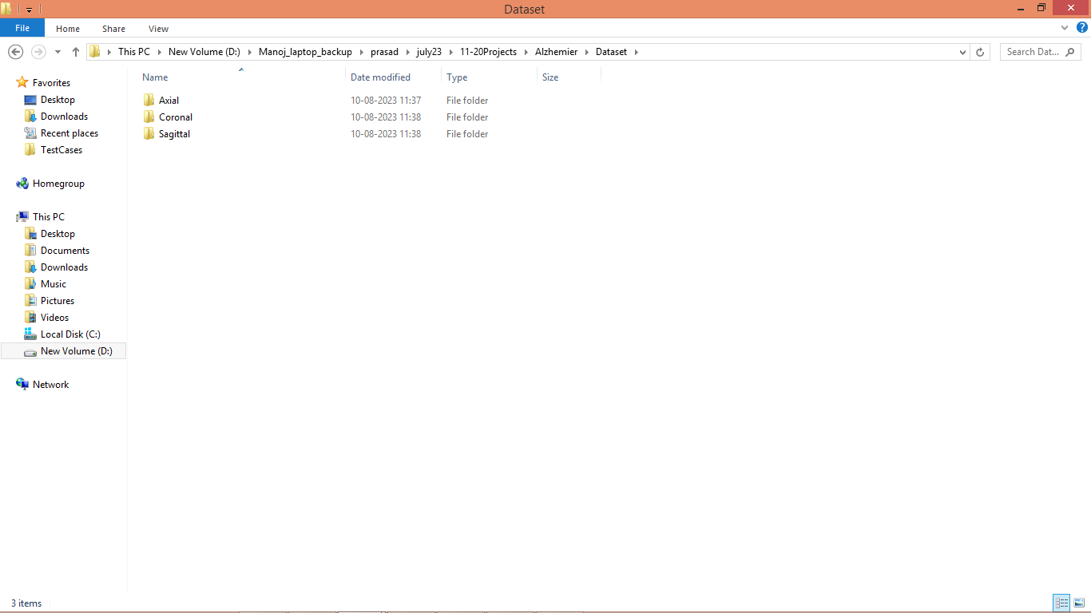

In above screen we have 3 folders for each region view and just go inside any folder to view related images

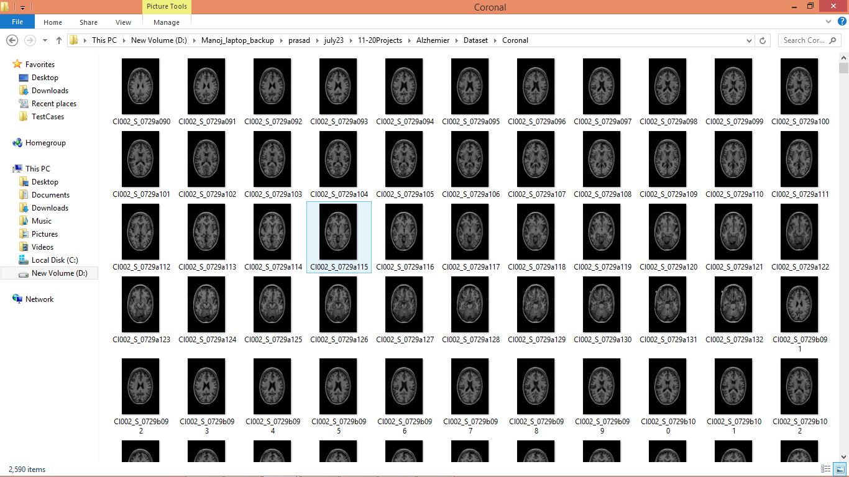

In above screen we can see images used to train models.

Extension Concept

In propose work LENET was used with Maxpool2D and without any dropout layer so as extension we have modified LENET with extra layer called Maxpooling2D which is newer and consistent layer compare to existing Maxpool2D and can help in improving accuracy. In extension we have added Dropout layer to optimized filtered features.

SCREEN SHOTS

To Run the application Click on “run.bat” file from the file location.

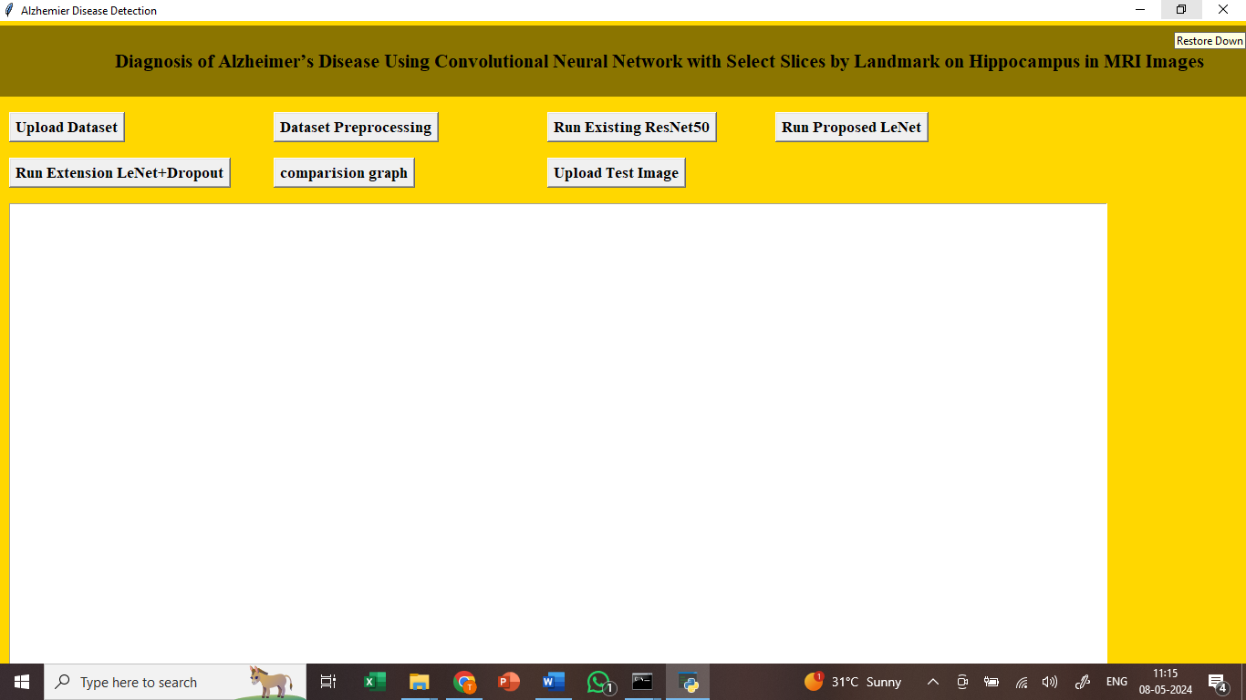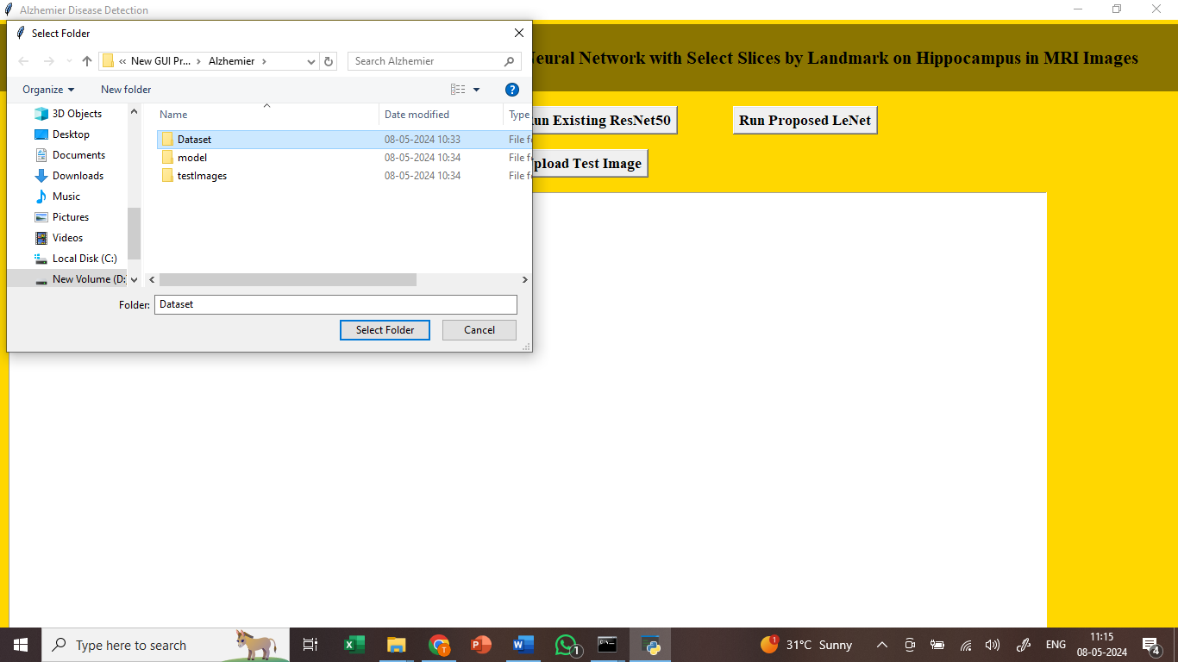

In above screen uploading dataset

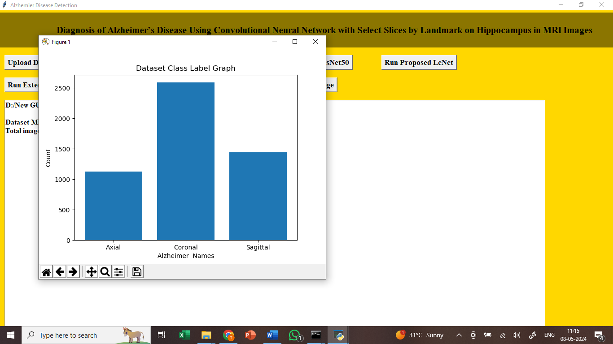

In above screen plotting graph of various labels found in dataset where x-axis represents label names and y-axis represents counts

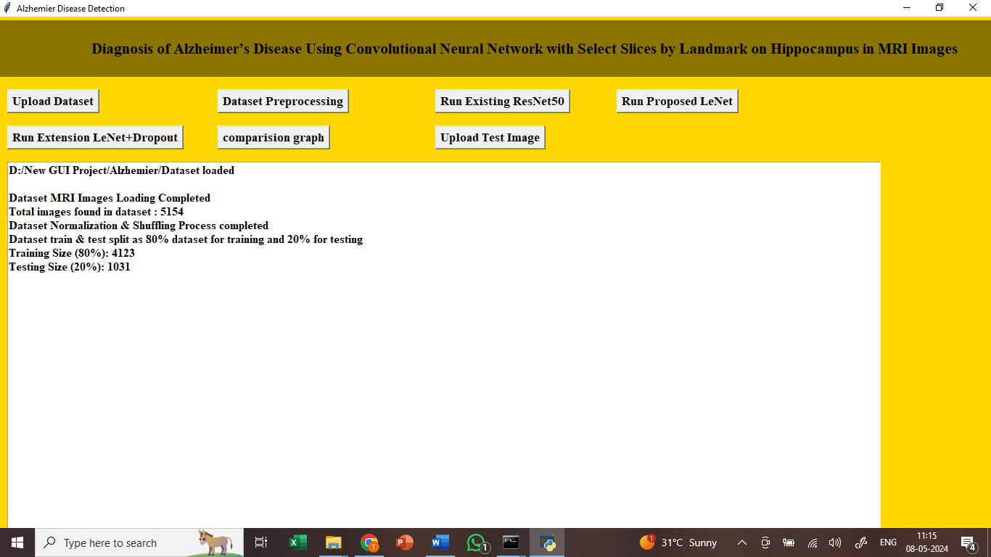

In above screen processing images features such as shuffling, normalization and splitting dataset into train and test where application using 80% images for training and 20% for testing

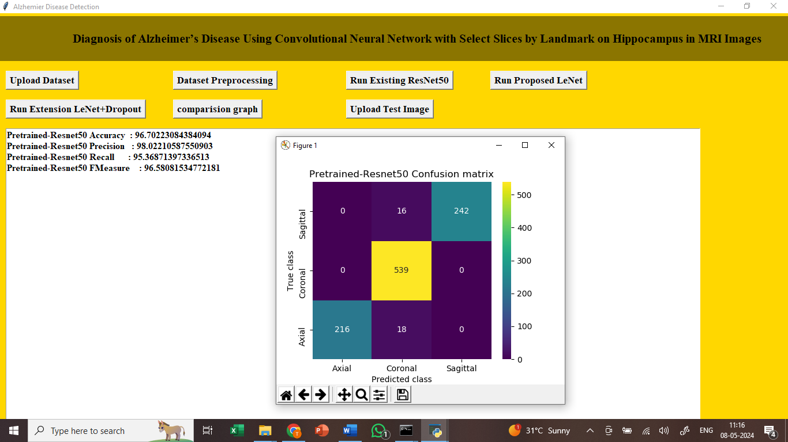

In above screen displaying Resnet50 output where blue colour text displaying accuracy, precision, recall and FSCORE from individual classes and then displaying overall accuracy as 96% and then we can see other metrics overall values and then in confusion matrix graph x-axis represents Predicted Labels and y-axis represents True Labels where different colour boxes represents correct prediction count and all blue boxes represents incorrect prediction count which are very few.

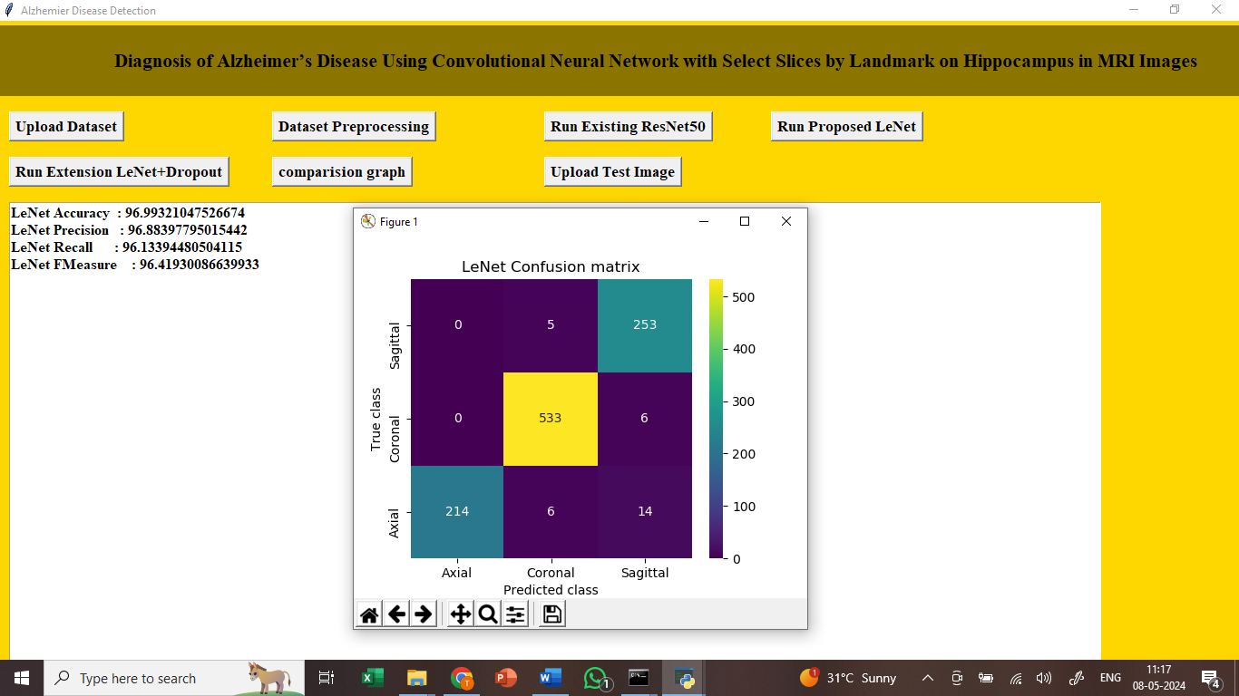

In above screen for LENET we can see individual class metrics and overall metrics where LENET overall accuracy is 97.19% accuracy and can see other metrics

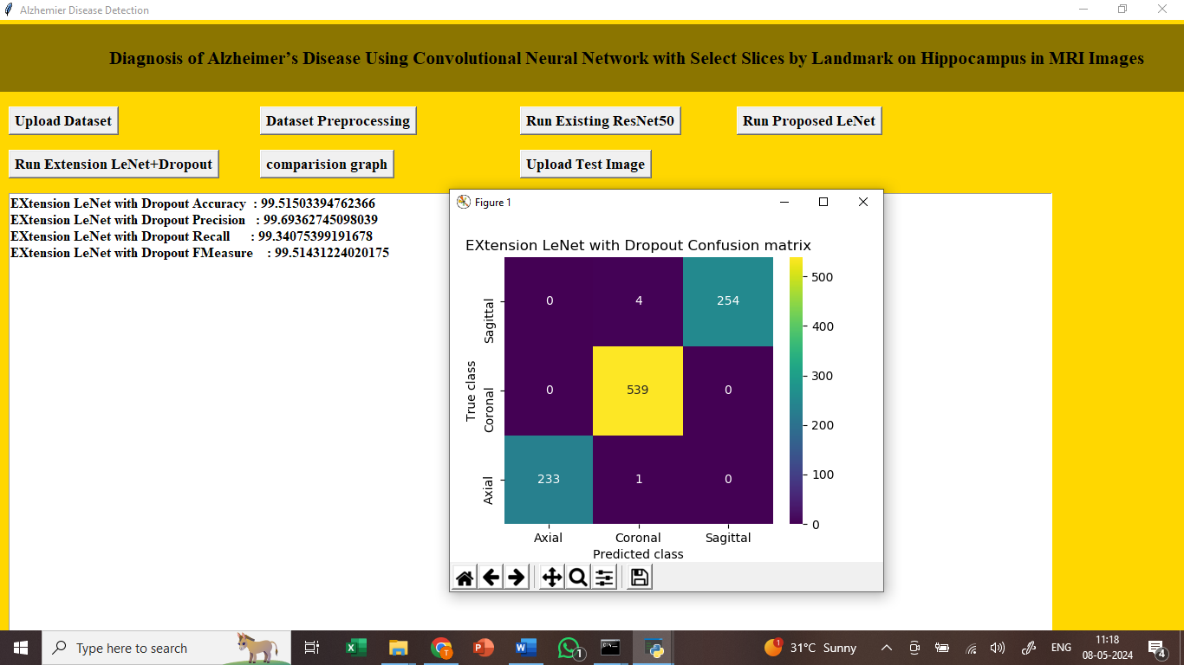

In above screen extension model got overall accuracy as 99.51% which is higher than other algorithms

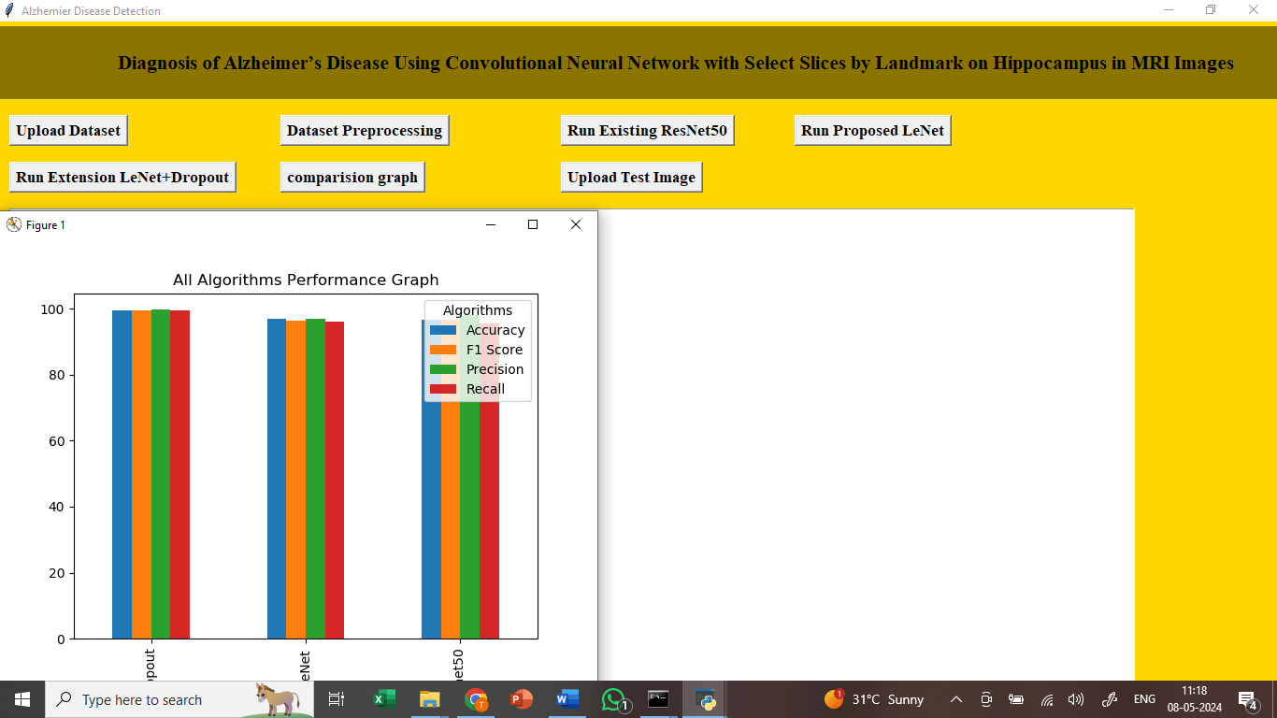

In above graph displaying performance of all algorithms in graph format where x-axis represents algorithm names and y-axis represents accuracy and other metrics in different colour bars and in all algorithms extension got high performance

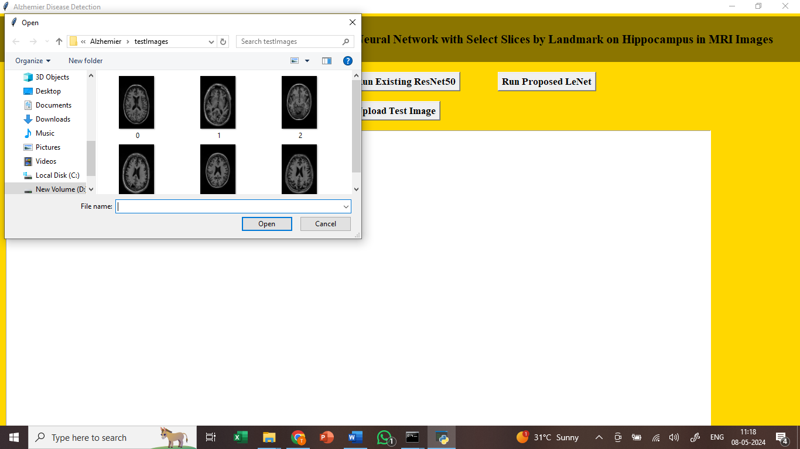

In above screen uploading test images

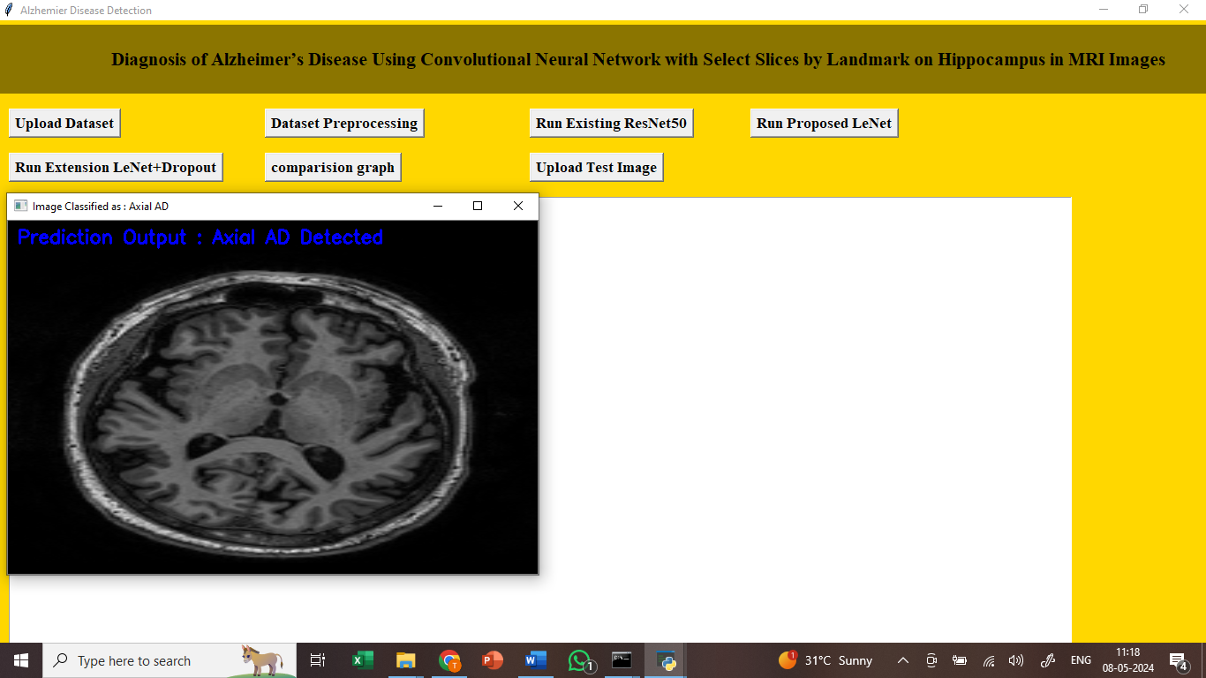

In above screen given test image is predicted as ‘Axial AD Detected’